Ideation Phase
Brainstorm & Idea Prioritization

Date | 28 January 2026
Team ID | LTVIP2026TMIDS85199
Project Name | AutoSage App using Gemini Flash
Maximum Marks | 4 Marks

Brainstorm & Idea Prioritization:
Brainstorming provides a free and open environment that encourages everyone within a team to participate in the creative thinking process that leads to problem solving. Prioritizing volume over value, out-of-the-box ideas are welcome and built upon, and all participants are encouraged to collaborate, helping each other develop a rich number of creative solutions.
Link: https://app.mural.co/t/bookorder0417/m/bookorder0417/1750771118627/79ec7991466208f26ea8dd22912d5481f0bcf596?sender=u427be78f24cc5d79ea230073
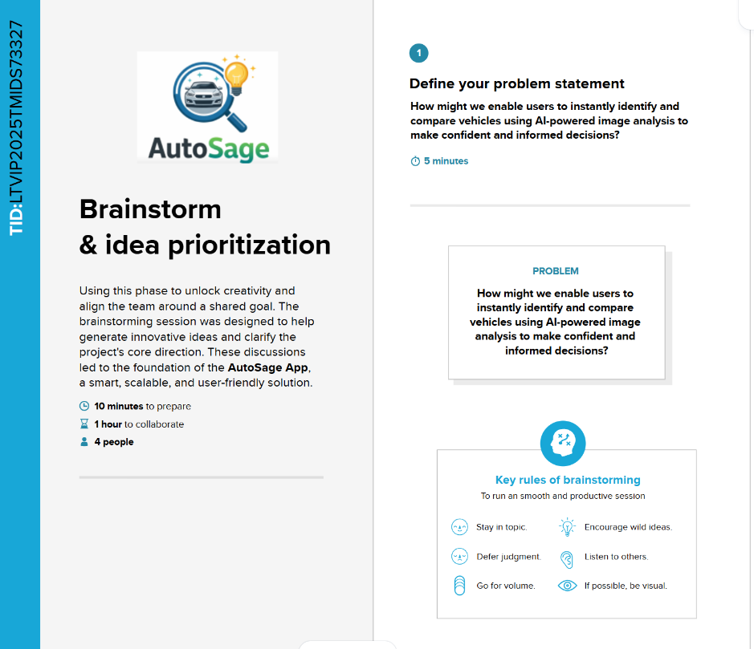
Step-1: Team Gathering, Collaboration and Select the Problem Statement

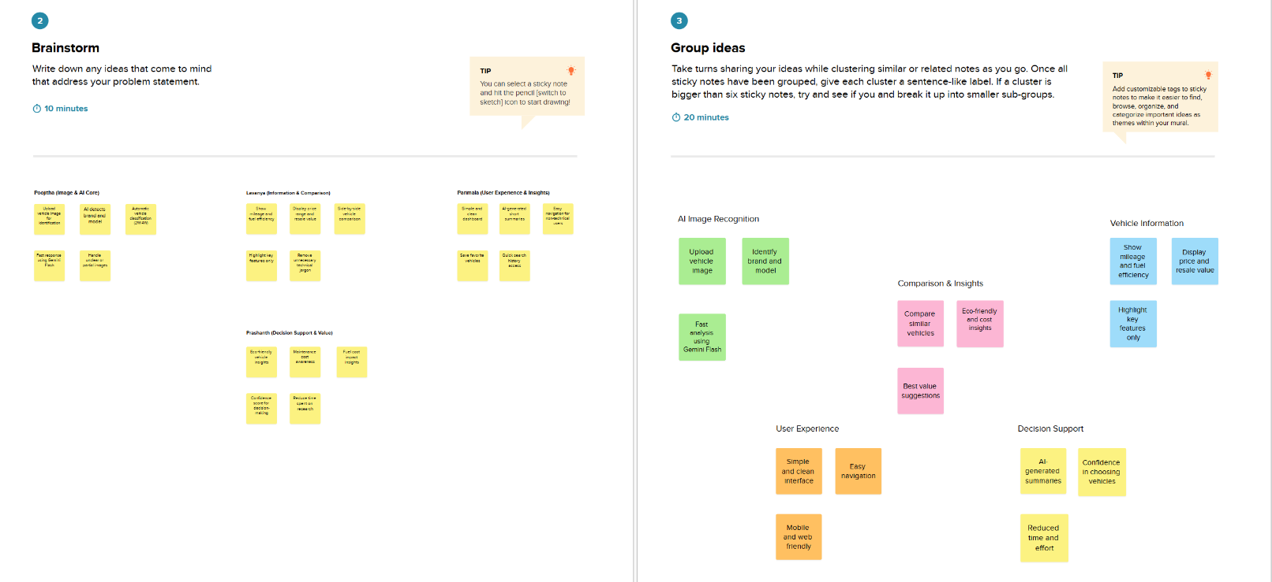
Step-2: Brainstorm, Idea Listing and Grouping

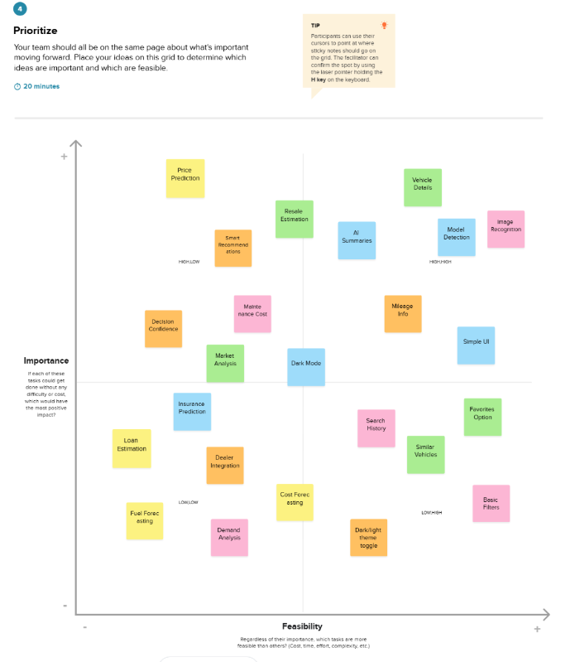
Step-3: Idea Prioritization

